**Snowflake Health Check Guide**



|  |  |
| --- | --- |
| Product Version | 4.8.0 |
| Document Type | Health Check Preparation Guide |
| Authors | Snowflake Data source Team |
| Reviewer | Red Team & Architects |
| Approver | CTO |
| Total Pages | 10 |
| Document Status | Draft |

Table Of Contents

1.1 Objectives 2

1.2 Architecture 2

1.3 Pre-requisite 2

1.4 Download Snowflake Metadata for health check. 3

1.5 Output Files 5

Document Version Record

|  |  |  |  |
| --- | --- | --- | --- |
| Date | Version # | Author | Remarks / Reason |
| 02-May-23 | 1.0 | Dev Team | New Document |

## Objectives

Health check download for snowflake unravel product.

## Architecture

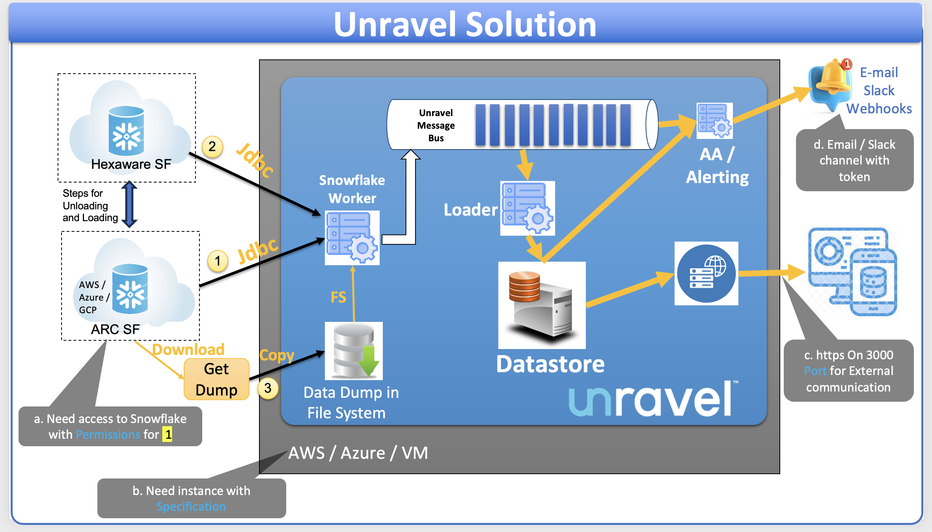

## Pre-requisite

1. **Snowflake account Access** 
   1. Health check data download from snowflake
      1. Create or select a user in snowflake, which has read access to Snowflake#Account_usage & Snowflake#Information_Schema.
      2. Grant selects for unravel user on schema SNOWFLAKE.ACCOUNT_USAGE & SNOWFLAKE.INFORMATION_SCHEMA.
      3. User should have permission to create stage and file format.
      4. Snowsql 1.2.27 should be installed
      5. Python3 should be available
      6. snowflake-connector-python required to execute snowflake queries in python (Refer the steps here - https://docs.snowflake.com/en/developer-guide/python-connector/python-connector-install).

## Download Snowflake Metadata for health check.

The following scripts let you download the account usage information from your Snowflake account.

* **snowsql_download_data.sql**: Downloads Snowflake metadata or telemetry data.
* **snowsql_show_wareshouses.sql**: Downloads Snowflake warehouse's data.
* **snowflake_query.py**: Downloads Snowflake warehouse parameters

Do the following to download Snowflake metadata:

1. Download the download/upload scripts from this location:

<https://github.com/unraveldata-org/snowflake-data-loader/tree/main/script>

1. Using SnowSQL connect to a Snowflake account. This account must have access to creating **stage** and **file** format.
2. Execute the **snowsql_download_data.sql**script with the required arguments to download the metadata from Snowflake **#account_usage** views. Refer to the following list of arguments for more details:

**Step-1**:

Note : ${variable} -> need to be modified as per site credentials and data

Once you run the script, it will prompt for the password.

snowsql -f ${downloaded-path}/snowsql_download_data.sql -d ${db} -s ${schema} -r ${role} -a ${account} -u ${user} -w ${warehouse} -o variable_substitution=true -o log_file=${script output file path/filename} --variable path=$(local/path/to store/downloaded metadata) --variable stage_name=unravel_stage_name --variable file_format=unravel_file_format

For example:

snowsql -f “snowsql_download_data.sql” -d unravel_db -s unravel_schema -r accountadmin -a rtb81672.us-east-1 -u smajumdar -w unraveldata -o variable_substitution=true -o log_file=./snowsql_download_data.log --variable path=/opt/unraveldata/ --variable stage_name=unravel_stage --variable file_format=unravel_file_format

| Parameter | Description |
| --- | --- |
| -f | Specify the file name of the script that is executed. Either specify the fully qualified name or just filename from the current directly.  For Windows: Please put the parameter value in double quotes (“”) |
| -d | Specify the database used for the script execution. |
| -s | Specify the name of the schema name used for the script execution. User should have **rights to create the stage and file formats under this** schema. |
| -r | Specify the role of the user who executes the script. |
| -a | Specify the Snowflake account, which will be used for the script execution. |
| -u | Specify the username of the Snowflake user who executes the script. |
| -w | Specify the Snowflake warehouse. |
| -o log_file | Specify the path to the log file that will be generated when you execute the script.  If any issues with the relative path, please provide absolute path. |
| -o | Provide the output-related arguments to get the logs in the specified path and format. |
| -o variable_substitution | Enable the variable substitution switch in the script. Some variables are used in the script for which the values must be passed from the CLI. Set this to **true**. |
| --variable path | Specify the local path to store the downloaded Snowflake system metadata. |
| --variable stage_name | Specify the stage name, which is used to keep the temporary files for download and upload. |
| --variable file_format | Specify the file format name, which is used by upload/download scripts. |

After the script is executed, the Snowflake metadata gets downloaded to the specified location.

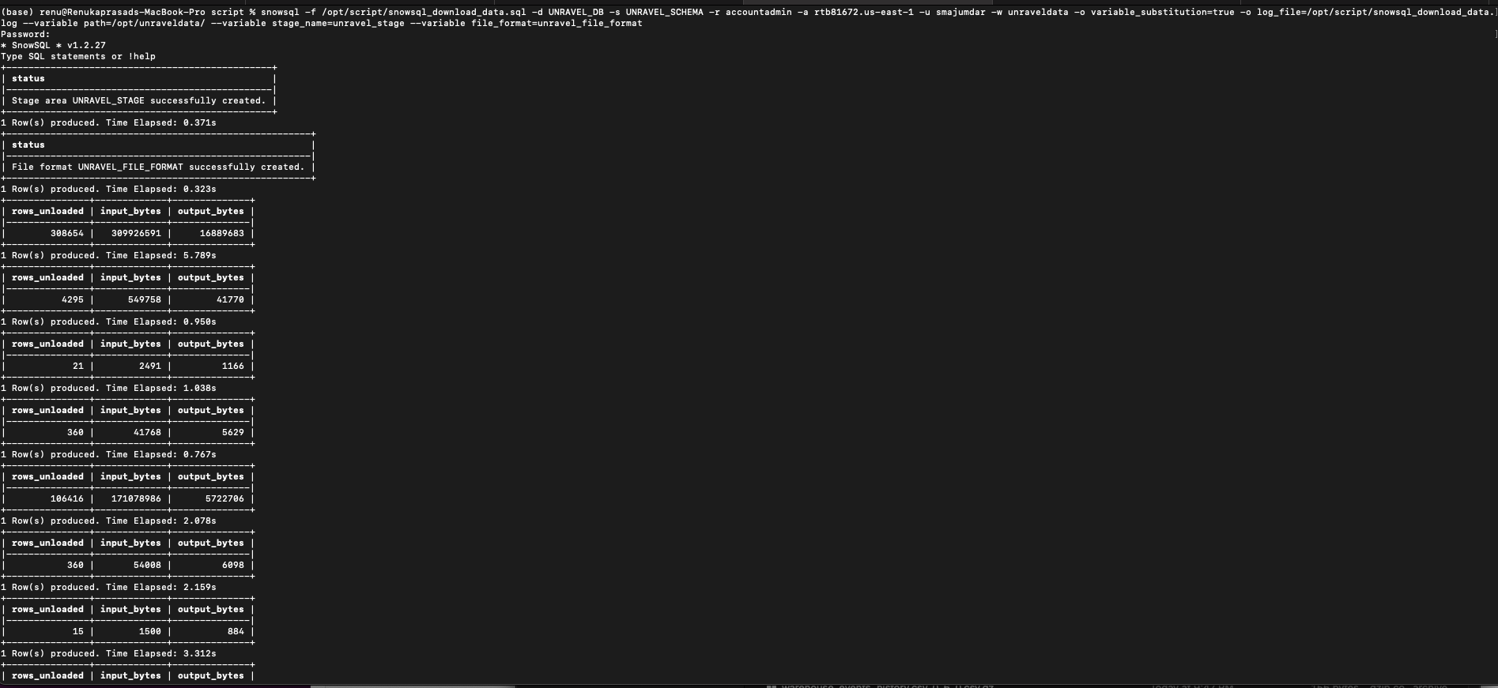

**Step-2**:

Execute the snowsql_show_wareshouses.sql script with the required arguments to download the warehouse data. Refer to the following list of arguments for more details:

Once you run the script, it will prompt for the password.

snowsql -f ${downloaded-path}/snowsql_show_wareshouses.sql -d ${db} -s ${schema} -r ${role} -a ${account} -u ${user} -w ${warehouse} -o output_format=csv -o output_file=${path}/warehouses.csv -o variable_substitution=true

snowsql -f /opt/script/snowsql_show_wareshouses.sql -d unravel_db -s unravel_schema -r accountadmin -a rtb81672.us-east-1 -u smajumdar -w unraveldata -o output_format=csv -o output_file=/opt/unraveldata/warehouses.csv -o variable_substitution=true

| Parameter | Description |
| --- | --- |
| -f | Specify the file name of the script that is executed. Either specify the fully qualified name or just filename from the current directly.  For Windows: Please put the parameter value in double quotes (“”) |
| -d | Specify the database used for the script execution. |
| -u | Specify the username of the Snowflake user who executes the script. |
| -s | Specify the name of the schema name used for the script execution. |
| -r | Specify the role of the user who executes the script. |
| -a | Specify the Snowflake account, which will be used for the script execution. |
| -o | Provide the output-related arguments to get the logs in the specified path and format. |
| -o variable_substitution | Enable the variable substitution switch in the script. Some variables are used in the script for which the values must be passed from the CLI. Set this to **true**. |
| -o output_file | Specify the path to the output file generated on script execution.  Generated filename should be ‘warehouses.csv’ as mentioned in the command/example. Don’t change the filename here.  **Note**: The output_file path should be same as the path mentioned in the **snowsql_download_data.sql** command  If any issues with the relative path, please provide absolute path. |
| -o output_format | Specify the output file format on script execution. This is in CSV format. |

After the script is executed, the warehouse data gets downloaded in CSV format at the specified output location.

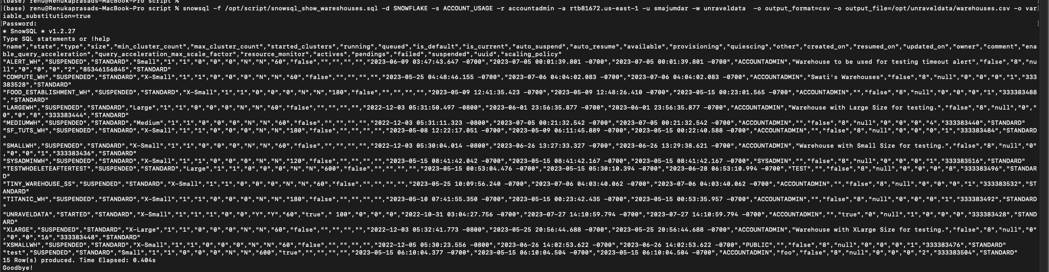

**Step-3**:

Execute the snowflake_query.py script with the required arguments to download the warehouse parameters data. Refer to the following list of arguments for more details:

python3 /opt/script/snowflake_query.py --user '${user}' --password '${password}' --account '${account}' --warehouse '${warehouse}' --database '${db}' --schema '${schema}' --out '/opt/unravel' --role ${role}

For example:

python3 /opt/script/snowflake_query.py --user 'smajumdar' --password 'Password' --account 'rtb81672.us-east-1' --warehouse 'unraveldata' --database 'SNOWFLAKE' --schema 'ACCOUNT_USAGE' --out '/opt/unraveldata' --role 'accountadmin'

| Parameter | Description |
| --- | --- |
| --user | Specify the name of the Snowflake user for the script execution. |
| --password | Specify the Snowflake user account passcode. |
| --database | Specify the database used for the script execution. |
| --schema | Specify the name of the schema that must be used to for the script execution. |
| --role | Specify the role of the user. |
| --account | Specify the Snowflake account, which will be used for the script execution. |
| --out | Specify the path to the output folder. |

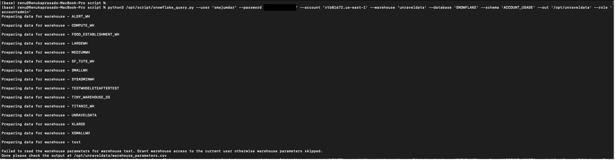

## Output Files

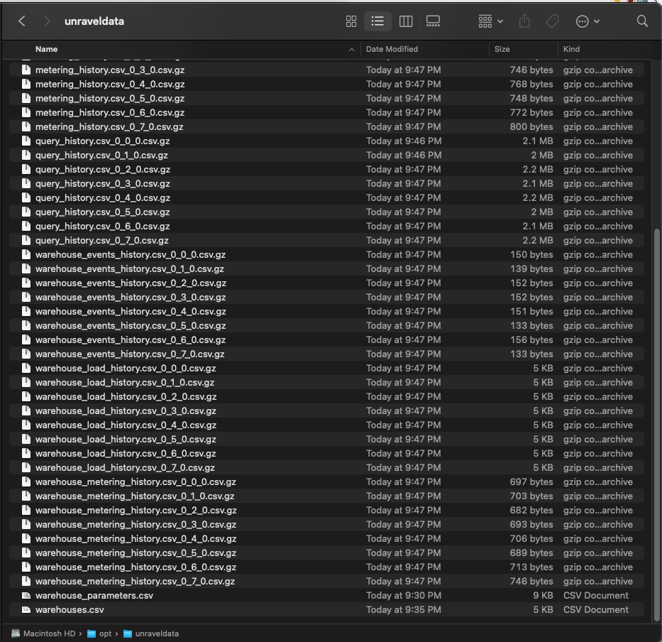

## Video Guide

<https://drive.google.com/open?id=13FvL6XTOzvTYtVAI2MZRRzeOWx0Y_s2r&usp=drive_fs>